**Next meeting will be Thursday Dec. 4th**

KEY CLUB NEWS



SHS Key Club

Thursday, Nov 6th, 2014

Kudos to the Key Club for raising $50 for UNICEF! Thank you to all who voted!

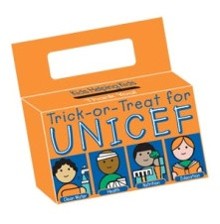

Operation Christmas Child will begin soon! We will be needing supplies and volunteers to fill shoe boxes. Help us reach our goal!

Bell-Ringing will begin this month and continue through December see Mrs. Marinucci for details and sign-up today!

Our annual ugly sweater contest will also be held next month before Christmas vacation!

**Tis’ the season to give back!**

Tutoring is ongoing at **the  Middle School: Mondays and Wednesdays**

**Tutoring**

The Otis Spunkmeyer was a great success! Orders can be picked-up next Wednesday Nov. 12th in Mrs. Marinucci’s room 341!

There is a new volunteer opportunity that starts this month and ends in February. Something To Do Saturdays will be held Saturdays from 10-1 at the middle school. Volunteers are needed to help out with this art program. For more information please see Mrs. Marinucci.

**Something To Do Saturdays**

***Please get your dues to a treasurer by Friday!***Dues are $10 for returning members and $20 for new members. If you are a new member please provide a shirt size to the secretary.

# Dues are officially due!

## There are a few ongoing community service oppurtunities!

**We are now collecting cans for the Ronald McDonald house. All cans are due Nov. 20th! Please donate!**

**Show your “K” in every way!**

**This Friday in honor of Key Club week post a status or tweet about what Key Club means to you! Use the #SHSKeyClub**

**Happy Key Club Week!**