aaaa­­

Key ClubNews

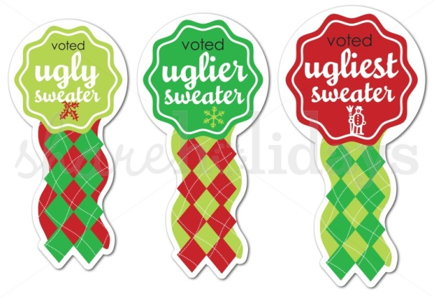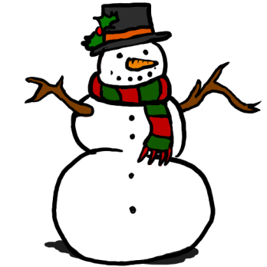**­**

**We need some volunteers!**

**Aitken Elementary will be holding an Evening of Giving next Thursday Dec. 18th. Volunteers are needed to set up craft tables and assist elementary students as they make crafts. Please sign up today!**

**Volunteers are also needed to stand by Toys for Tots collection bins at Chardonnay’s and the Grist Mill. For more details on the event or to sign-up please visit the Guidance Office ASAP!**

‘Tis the Season to Rock Ugly Sweaters

December 19th breakout those ugly sweaters for our annual Ugly Christmas Sweater Contest!

**Ongoing Events:**

**There is still tutoring going on at the Middle School!**

**Something to do Saturdays have started and will continue through January here are the dates:**

**Dec. 13, 20**

**Jan. 10, 17, 24, 31**

**This month there is also bell-ringing see Mrs. Marinucci for details!**

**Thank you to the “elves” who helped out at the Town Hall Tree Lighting last week!**

SHS KEY CLub

Thursday December 11th, 2014

Thursday December , 2014

**[](http://ccs.infospace.com/ClickHandler.ashx?ld=20141211&app=1&c=whiteskycc&s=whiteskycc&rc=&dc=&euip=24.34.36.255&pvaid=703e3403978b4b3cb62ccb2668ae743d&dt=Desktop&fct.uid=9a95cddead934a5781abbc9c9942fe32&en=b4e6WfB%2f7Y8X4igQCwGyHAeZXPK5S7XY%2bNvHwNGT0%2bvkPEBBCuKVzg%3d%3d&du=http%3a%2f%2fwww.clker.com%2fcliparts%2fD%2fu%2f9%2fC%2fU%2fD%2fsnowflake-hi.png&ru=http%3a%2f%2fwww.clker.com%2fcliparts%2fD%2fu%2f9%2fC%2fU%2fD%2fsnowflake-hi.png&ap=1&coi=772&cop=main-title&npp=1&p=0&pp=0&ep=1&mid=9&hash=6E65020DC01ECCEDDB855F1E6FE8F56F)**

Details on the Toys for Tots community service opportunity:

Volunteers are needed for these dates:

|  |  |  |
| --- | --- | --- |
| Thursday, 12/11 6:00-8:00  **Chardonnay’s** |  |  |
| Thursday, 12/11 6:00-8:00  **Grist Mill** |  |  |
| Friday, 12/12 6:00-8:00  **Chardonnay’s** |  |  |
| Friday, 12/12 6:00-8:00  **Grist Mill** |  |  |
| Thursday, 12/18 6:00-8:00  **Chardonnay’s** |  |  |
| Thursday, 12/18 6:00-8:00  **Grist Mill** |  |  |
| Friday 12/19 6:00-8:00  **Chardonnay’s** |  |  |
| Friday, 12/19 6:00-8:00  **Grist Mill** |  |  |

**Sign-ups are in Guidance!**

|  |  |
| --- | --- |
|  |  |
|  |  |
|  |  |
|  |  |
|  |  |
|  |  |
|  |  |
|  |  |

**[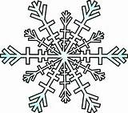](http://ccs.infospace.com/ClickHandler.ashx?ld=20141211&app=1&c=whiteskycc&s=whiteskycc&rc=&dc=&euip=24.34.36.255&pvaid=703e3403978b4b3cb62ccb2668ae743d&dt=Desktop&fct.uid=9a95cddead934a5781abbc9c9942fe32&en=b4e6WfB%2f7Y8X4igQCwGyHAeZXPK5S7XY%2bNvHwNGT0%2bvkPEBBCuKVzg%3d%3d&du=http%3a%2f%2fwww.clker.com%2fcliparts%2fl%2fE%2fM%2fc%2fu%2fn%2fsnowflake-hi.png&ru=http%3a%2f%2fwww.clker.com%2fcliparts%2fl%2fE%2fM%2fc%2fu%2fn%2fsnowflake-hi.png&ap=6&coi=772&cop=main-title&npp=6&p=0&pp=0&ep=6&mid=9&hash=B6AFA015EE404F523E0452BA336829B8)**

**Our next meeting will be held Thursday January 8th 2015!**

**Get excited for the New Year!**

**A New Year means new community service opportunities!**

**Key Clubbers can also look forward to DCON (District Convention)! Event details will be provided in future newsletters!**

Happy Holidays Key Clubbers!