

**Next meeting will be Thursday Nov. 6th**

KEY CLUB NEWS

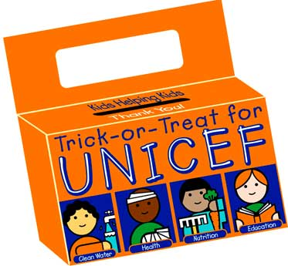

*If you cannot attend a meeting please let one of the secretaries know!*

*The next meeting is novermber 6th!*

Thank you to all who volunteered at Pumpkin Somethin’ last Saturday!

**Dues are Due!!**

***SHS PINK OUT!!***

***Join SHS in honoring Breast Cancer Awareness month and wear pink this Friday Oct.*** ***17th!***

**SHS Key Club**

Thursday Oct. 16th, 2014

**Next month**

**We will be collecting cans for the Ronald McDonald house**

**Nov. 3rd-7th is KEY CLUB WEEK**



Upcoming Events

## UNICEF

**This year for UNICEF we are having students vote! Next week during lunches students can vote for a teacher of their choice to wear a costume (supplied by the Key Club Exec. Board) on Oct. 31st. The price to vote is $2 and all the proceeds will go to UNICEF!**

***The Otis Spunkmeyer fundraiser is over!***

## Sign-up For Babysitter’s Club

**If you are interested in Babysitter’s Club talk to our Co-Chairs Michaela Cabral and Erica Kenneally. Michaela is in charge of the Aitken babysitting opportunities and Erica is head of the Martin school opportunities. Also join the Facebook group SHS Babysitter’s Club for up to date opportunities!**

**Dues are $10 for returning members and $20 for new members. If you are a new member please provide a shirt size to the secretary. Checks can be made out to the Town of Seekonk and please get your dues to a treasurer as soon as possible!**

**Please give your order forms to Mrs. Marinucci ASAP! Thank you to all who participated!**